How to generate report on Department of Family Medicine publications:
- Use any web browser and go to https://dfm-publications-report.streamlit.app/
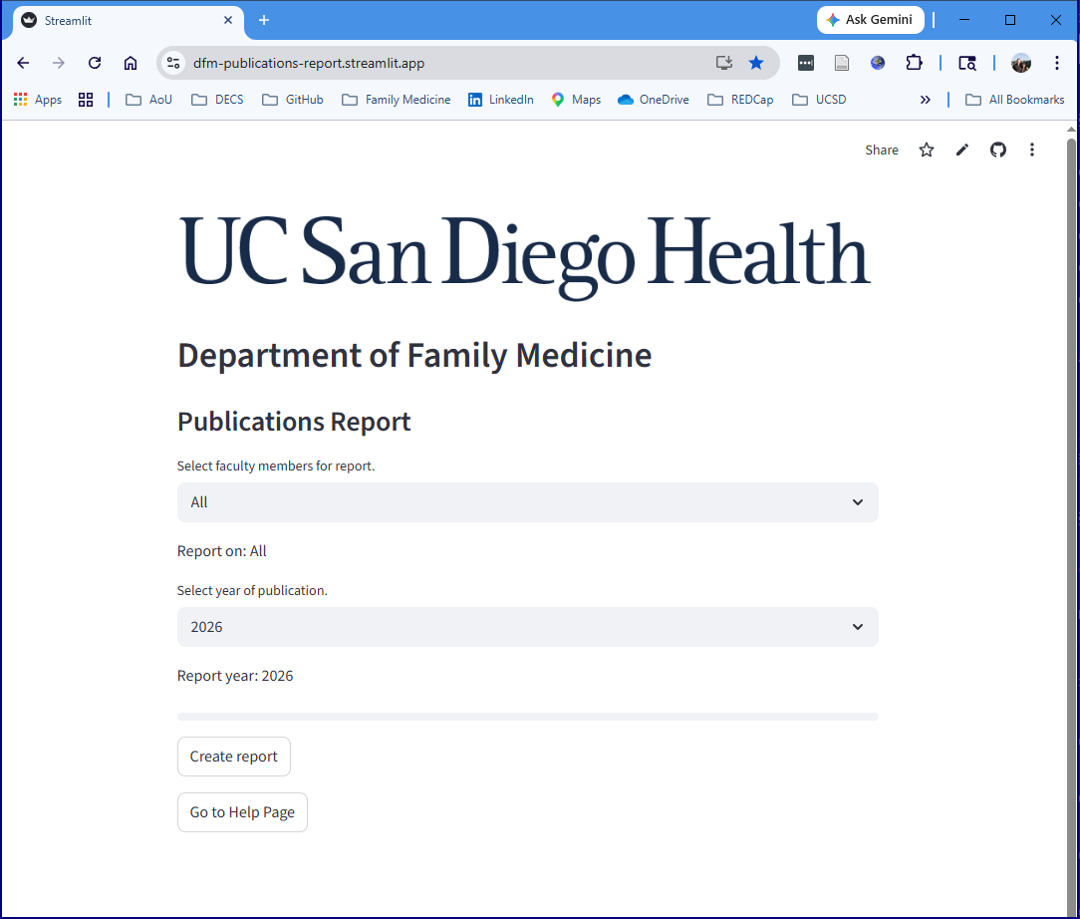
- Select faculty member (or all faculty members)
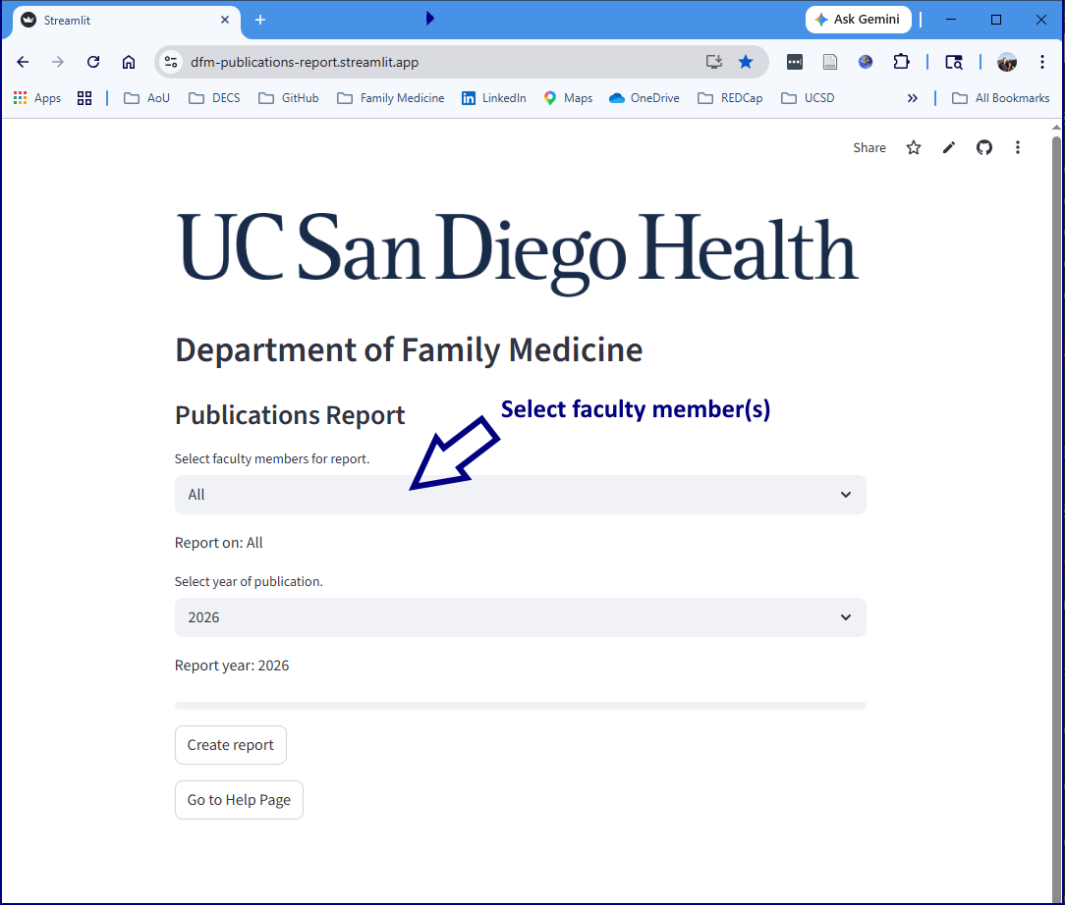
- Select year of publication
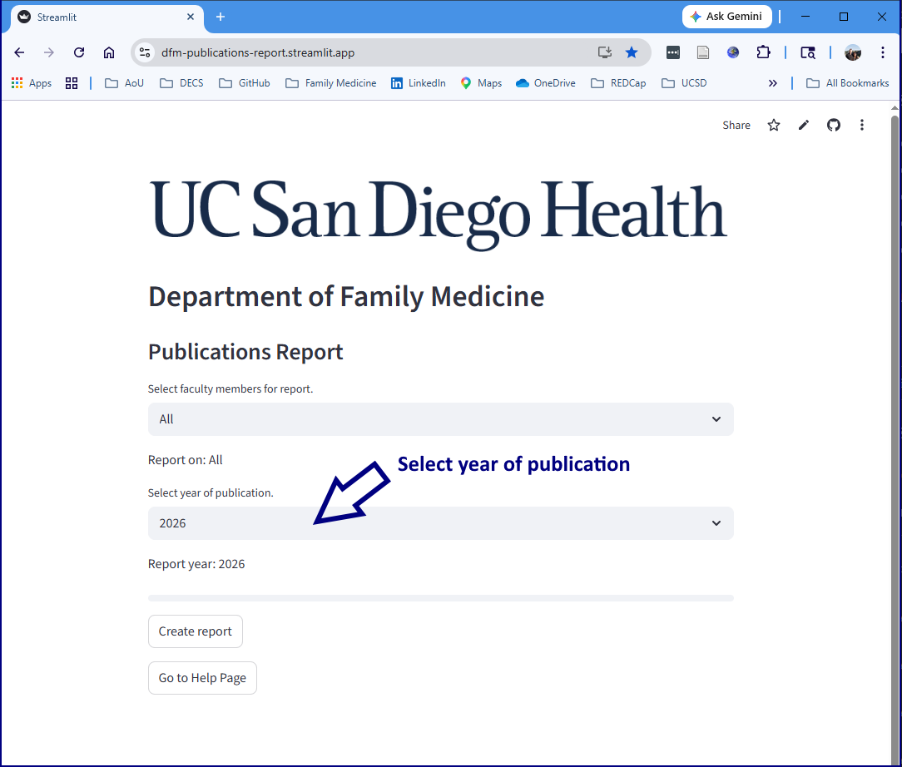
- Press Create report button
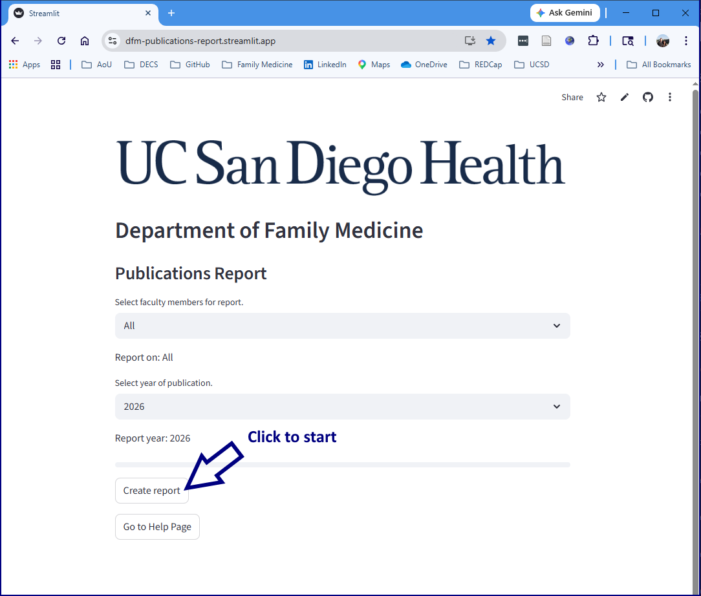
Report will be automatically displayed, along with a download button.

